**Big Mountain Ski Resort Ticket Price Analysis Summary**

Across the United States there are 330 ski resorts within the same market segment as Big Mountain, and one of 12 within the great state of Montana. Currently our approach to setting ticket prices is simply adding a premium over the national average. With a ticket price of $81 for both weekday and weekend skiers and the national average coming in at roughly 64$ per ticket, Big Mountain applies roughly a 25% premium. This may seem like alot compared to the average but is Big Mountain overcharging or undervaluing itself? I am glad to report that our analysis says it’s the latter.

With a vertical drop of 2353 feet, 3 fast quads, 105 runs, 600 acres of guaranteed skiable area, 14 chair lifts and 3000 acres of skiable terrain, Big Mountain is positioned feature-wise as one of the top resorts in its market segment. Based on our models, those are the features most correlated to having an impact on ticket prices and Big Mountain sits near the top nationally in all of those categories. Since our analysis failed to support any price and feature correlation by state, we feel confident in the predicted ticket price.

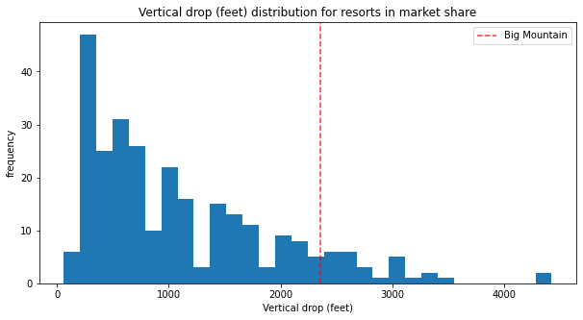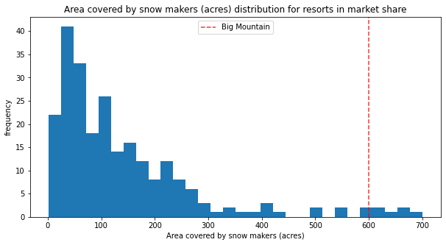

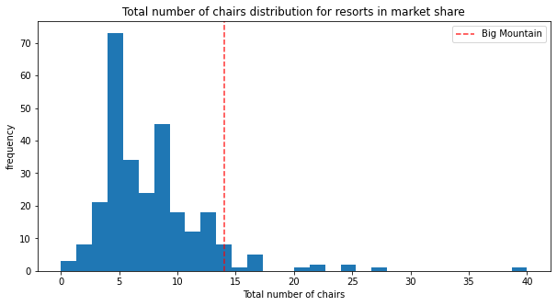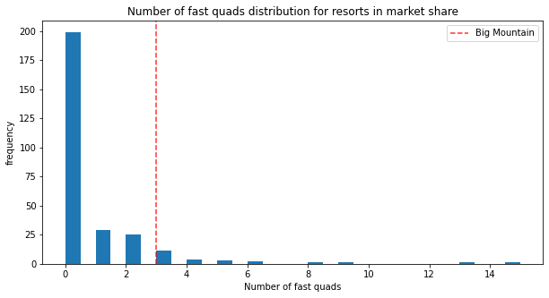

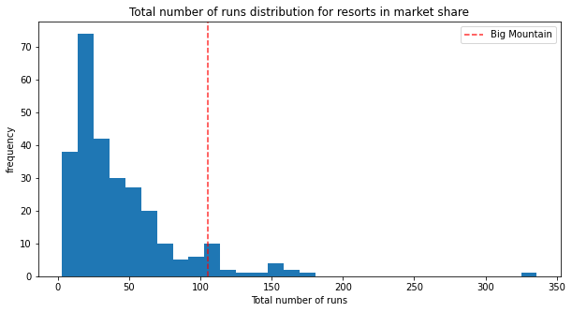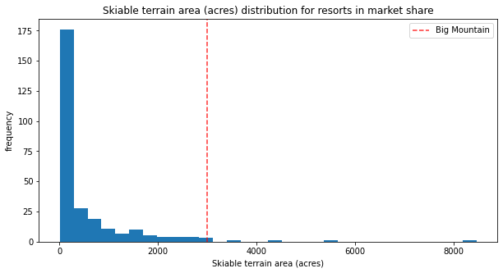

Based on these assets, our models predict that Big Mountain Ski resort should be charging a price of $94.22 per ticket. Based on 350,000 visitors per year spending an average 5 days skiing, the increased ticket price would generate a little over 22 and a half million extra dollars in revenue each year, and that’s including the operating costs of the new lift.

Regarding the given scenarios for generating additional revenue and asset investment guidance, the most lucrative and least damaging scenario’s are scenario 1 and 2.

**Scenario 1** : Closing one run would have no impact on predicted ticket price. Closing 2 runs would reduce ticket price by roughly $0.40 per ticket, generating a revenue loss of $700,000. The sweet spot looks to be closing 3-5 runs, closing 3 produces the same $0.66 price reduction as closing 5 runs therefore closing 5 would be ideal. Doing so would theoretically reduce revenue by $1,165,500. Continuing further reduces ticket price greatly. Unfortunately without a value of how much closing a run saves in operation costs we are unable to give a more accurate number

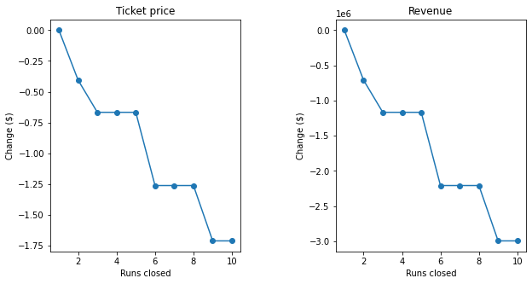

**Scenario 2**: Adding an additional run with an additional drop of 150ft, increasing the total drop to 2500ft, almost half a mile, and adding an additional chair lift produced an additional ticket price increase of $2.29 on top of the predicted ticket price based on Big Mountain’s current facilities. Subtracting additional operating costs of an additional lift, assuming it’s the same as the recently installed lift, would generate an additional $2,467,246 in revenue per year. Again, without knowing the cost of operating a run, the true effect on revenue cannot be estimated.

The other scenarios produced minimal benefit to revenue. Combining Scenario 1 and 2 would be the most lucrative. Shutting down 6 of the least popular runs and replacing it with 1 new run netting only 5 discontinued run’s. This course of action would increase the resort’s total drop by 150ft which would increase yearly revenue by $2,467,246 plus the additional cost savings from shutting down.

(*Note for grader, my notebook showed Scenario 3 as very lucrative indicating a price increase of $9.75 per ticket for only adding 2 more acres of snow machine covered ski area however common sense tells us that is more than likely an error.)*